[1]

**An efficient pipeline for biophysical modeling of neurons**

Nathaniel Opsal, Pete Canfield, Tyler Banks, and Satish S. Nair, Senior Member, IEEE

*Abstract*— **Automation of the process of developing biophysical conductance-based neuronal models involves the selection of numerous interacting parameters, making the overall process computationally intensive, complex and often intractable. A recent insight about the possible grouping of currents into distinct modules associated with specific neurocomputational properties also simplifies the process of automated selection of parameters. The present paper adds a new current module to the previous report to design spike frequency adaptation and bursting characteristics, based on user specifications. We then show how our proposed grouping of currents into modules facilitates the development of a pipeline that automates the biophysical modeling of single neurons that exhibit multiple neurocomputational properties. The software will be made available for public download via our site cyneuro.org.**

# INTRODUCTION

Computational models of single neurons utilize a variety of formulations depending on the application. One such formulation, biophysical conductance-based model can provide improved realism in network models when investigating phenomena such as neuronal oscillations. Present single cell models have compartments varying from one in reduced order cells to over 1000 in morphologically complex cell models. Large neuronal network models typically use reduced order models of single cells to limit both computational overheads and parametric uncertainties. However, in such cases, it is important that the reduced order model neuron possess key neurocomputational properties including passive properties, current injection responses as well as possibly complex oscillatory dynamics,. We had previously hypothesized and successfully tested the hypothesis that in a single neuron, different sets of current modules might be responsible for neurocomputational properties such as passive properties (resting potential, time constant and input resistance), sub-threshold oscillations, and spike waveforms [1]. Furthermore, the hypothesis naturally suggested an approach, termed the ‘segregation method’, that was shown to facilitate the selection of single cell model parameters and to simplify the overall design. Such a simplification in design facilitates automation of the process of optimizing the numerous parameters associated with Hodgkin-Huxley formulations in the biophysical conductance-based models of single neurons.

Here we first extend the types of neurocomputational properties reported in [1] to include spike frequency adaptation and bursting. As a second contribution, we propose a pipeline to automate the design process using a recently reported machine learning scheme that includes Bayesian and fully connected neural network modules (simulation-based inference, sbi; [2]). We illustrate the proposed scheme using an example of a pyramidal neuron in the CA3 region of the hippocampus that responds to stimuli with a rapidly adaptive burst waveform that then reduces to tonic spiking or to a continuously bursting phenotype, both of which are commonly found neural signatures. We then show that such a waveform output of CA3 neurons plays an important role in the generation of theta oscillations in the model hippocampal network. The goal is to develop a publicly accessible software tool that automates the process of designing a single cell using the segregation approach.

# Method

Models of single neurons were developed using experimental parameters from our collaborators and the literature, and implemented using the NEURON 7.4 simulator [3], with a fixed time step of 25 µs. We first describe a brief overview of the mathematical underpinnings of both single cell dynamics and of the segregation approach [1].

*Mathematical equations for voltage-dependent ionic currents:* The dynamics for each compartment (soma or dendrite) followed the Hodgkin-Huxley formulation as previously described [4] in eqn. 1,

$C_{m}dV_{s}/dt=-g_{L}\left(V_{s}-E_{L}\right)-g_{c}\left(V_{s}-V_{d}\right)-\sum{I_{cur,s}^{int}}-\sum{I_{cur,s}^{syn}}+I_{inj}$ (1)

where $V_{s}/V_{d}$ are the somatic/dendritic membrane potential (mV), $I_{cur,s}^{int}$ and $I_{cur,s}^{syn}$ are the intrinsic and synaptic currents in the soma, $I_{inj}$ is the electrode current applied to the soma, $C_{m}$ is the membrane capacitance, $g_{L}$ is the conductance of the leak channel, and $g_{c}$ is the coupling conductance between the soma and the dendrite (similar term added for other dendrites connected to the soma). The intrinsic current $I_{cur,s}^{int}$*,* was modeled as $I_{cur,s}^{int}=g_{cur}m^{p}h^{q}(V_{s}-E_{cur})$, where $g_{cur}$ is its maximal conductance, *m* its activation variable (with exponent *p*), *h* its inactivation variable (with exponent *q*), and $E_{cur}$ its reversal potential (a similar equation is used for the synaptic current $I_{cur,s}^{syn}$ but without *m* and *h*). The kinetic equation for each of the gating variables *x* (*m* or *h*) takes the form but without *m* and *h*). The kinetic equation for each of the gating variables *x* (*m* or *h*) takes the form

$\frac{dx}{dt}=\frac{x_{∞}\left(V,{\left[{Ca}^{2+}\right]}_{i}\right)-x}{τ_{x}(V,{\left[{Ca}^{2+}\right]}_{i})}$ (2)

where $x_{∞}$ is the steady state gating voltage- and/or Ca2+- dependent gating variable and $τ_{x}$ is the voltage**-** and/or Ca2+**-** dependent time constant. The equation for the dendrite follows the same format with ‘*s*’ and ‘*d*’ switching positions in eqn. 1. The procedure for selecting the channel currents and their model parameters are described next using an approach we proposed recently.  
*Segregation hypothesis in single cell design*. The hypothesis states that distinct current modules implement neurocomputational properties, e.g., passive properties (Vrest, input resistance, tau) and spiking properties in cartoon form in Fig.1. In this case, leak and the hyperpolarization-activated cation current H (passive module) are responsible for passive properties. Similarly, leak, transient sodium Nat and delayed rectifier Kdr currents set the spiking properties for the shaded ‘spiking module’. The activation functions are segregated to prevent overlap, i.e., the currents of each module start on the voltage axis only after the zone of action of the module to its left. Details related to the approach with additional modules can be found in [1].

*Design of the Nap-KM module as option 1 for adaptation/bursting properties*. To design the neurocomputational property of adaptation and bursting, we first add the transient sodium (Nap) +M type potassium (KM) module (known to provide this property to neurons [5]) to the ‘passive’ and ‘spiking’ modules in Fig. 1 that were described above. An example case hippocampal CA3 neuron with an adapting characteristic [6] is considered to illustrate the procedure. The neuron also has other spiking currents transient sodium (Nat), delayed rectifier potassium (Kdr), hyperpolarization-activated cation current (H) and leak currents, which are kept fixed here. The ranges for the adjustable parameters for Nap-KM modules of the CA3 neuron, based on biological reports, were as follows (units for g is mS/cm2 and for V1/s is mV): gNap – [1*10-5, 0.005], gKM – [5*10-6, 0.017], V1/2 Nap - [-65, -35], V1/2 KM - [-50, 0].

*Design of the CaS-CaT-sAHP module as option 2 for adaptation/bursting properties*. A second option to implement adaptation and busting is the set of currents that include a low-threshold Ca2+ (CaS), high-threshold Ca2+ (CaT) and the calcium-activated potassium (sAHP) currents.

A different class of the same hippocampal CA3 neuron that exhibits the bursting characteristic [7] is considered for this option. Similar to the case above, the ranges for the parameters for this set of current were as follows (units for g is mS/cm2 and for V1/s is mV): gCaS – [1*10-5, 0.017], gCaT– [1*10-5, 0.017], gsAHP – [1*10-5, 0.008], V1/2 CaS - [-33], V1/2 CaT - [-27.1].

# Results

The two options to model spike frequency adaptation and bursting into model neurons via the approach that groups currents into modules using a segregation approach is illustrated using an example case hippocampal neuron from our previous publication [8].

**Design of two current modules to implement spike frequency adaptation and bursting**

Nap-KM module. This module adds the neurocomputational property of adaptation and bursting, depending on the parameters of the two currents. Both channels can be segregated up to ~-60 mV in this model. Optimizing the parameters after implementing the segregation (Fig. 2A) resulted in the following parameter set that provided the adapting characteristic shown in Fig. 2B that matches the biological trace in [6] well: gNap =0.0005, gKM = 0.017, V1/2 Nap = -48, V1/2 KM = 35.

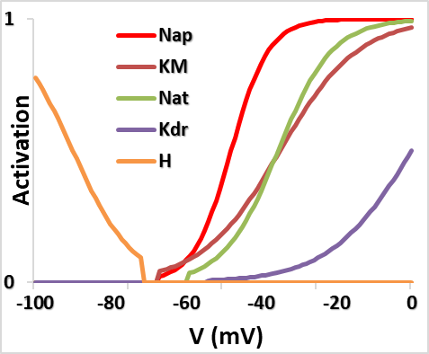

Figure 2A. Segregation of currents into three modules – passive (H), adapting/bursting (Nap, KM) and Spiking (Nat, Kdr) modules in the example hippocampal CA3 cell.

Adaptation happens when KM current builds up enough to counteract the Nap current. The time constant of KM controls the initial high frequency of the adapting characteristic. On the other hand, increasing gKM (~0.17) shuts off spiking and results in a bursting characteristic. Importantly, without such a segregation of the current modules, it was very difficult to hand-tune the parameters due to the interactions between the currents. Such interaction effects resulted in changes to spiking properties affecting passive properties, and so on. This makes the tuning process very difficult, for both hand- and automated-tuning scenarios [1]. For this particular neuron, the neuron becomes an endogenous spiker if segregation is not implemented (Fig. 2C).

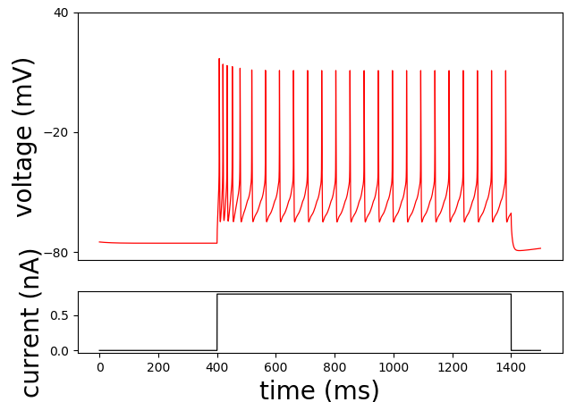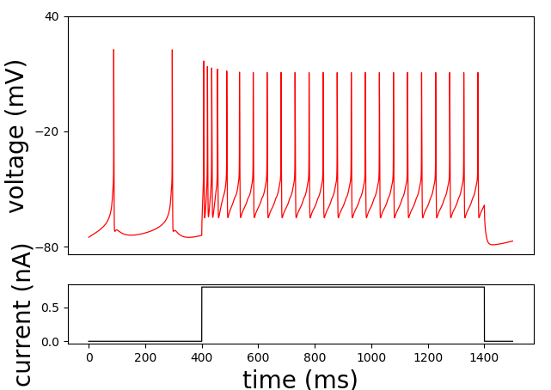

Figures 2B and 2C. Adapting CA3 Pyramidal cell when segregated (left) and unsegregated(right).

CaS-CaT-sAHP module: This second option to add adaptation/bursting involves three currents. CaS is segregated at -57.5. CaT and sAHP are unsegregated (Fig. 3). The parameter set after implementing the segregation scheme (Fig. 3A) and tuning are as follows: gCaS =0.00425, gCaT =0.001 , gsAHP = 0.005. These resulted in the bursting profile of Fig. 3B. Again, without such a segregation of the current modules, it was very difficult to hand-tune the parameters due to the interactions between the currents, and removing the segregation around the tuned values results in the plot in Fig. 3C.

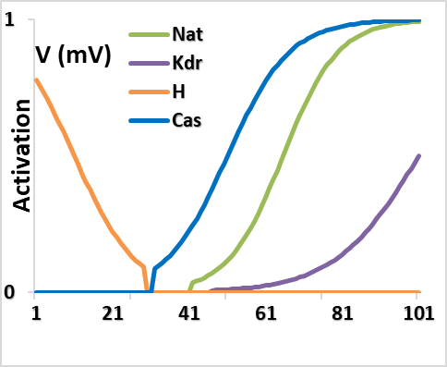

Figure 3A. Segregation of currents into three modules for the second option – passive (H), adapting/bursting (CaS, CaT and sAHP) and Spiking (Nat, Kdr) in the second option for example hippocampal CA3 cell.

Bursting is controlled in this module by tsAHP and tCa-pool. tsAHP can be increased or decreased largely independently to increase or decrease, respectively, the number of spikes per burst. Similarly, tCa-pool can be increased or decreased almost independently to increase or decrease, respectively, the inter-best interval.

Some interesting **neural dynamic characteristics** that we noted for the Nap-KM and CaS-CaT-sAHP modules were as follows (Fig. 3B): (i) the ranges of the inter-burst interval (IBI) for the Nap-KM module are set by the lower/higher biological ranges for the time constant of the KM current, of 46 ms and 120 ms, respectively (REF). The maximum spike frequency was 125 Hz. (ii) For the CaS-CaT-sAHP module, the minimum IBI was 120 ms, set by the minimum time constant for the Ca2+ pool to permit sAHP to activate. Ranges were not found to set the maximum on the IBI in this case. The maximum spiking frequency for this module was 77 Hz, set by the competing effects of CaS that raised the membrane potential to allow for faster spiking but also simultaneously increases activation of sAHP activation that causes inhibition.

Finally, the analysis provides the following **user tuning guidelines** for designing the Nap-KM module: increasing t_KM and gKM increases IBI; an increase in gNap increases spike frequency; number of spikes per burst can be increased by increasing gNap, increasing t_KM, or decreasing gKM with the latter being the least effective. Similar guidelines for tuning the CaS-CaT-sAHP module are as follows: increasing t_Ca2+pool and t_sAHP increase IBI; spike frequency can be increased by gCaS; spikes per burst can be increased by decreasing gCaT or gsAHP, or by increase t_sAHP.

Figure 3B. Spike frequency and Inter-Burst Interval limits for both bursting Modules.

**Adaptive bursts are important to generate theta oscillations in a network of CA3 cells**

Figure 4A. Power Spectral Density (PSD) of two independent network trails. A 15Hz Poison random input was supplied to a model hippocampal network. PSD was calculated for a non-bursting tonic CA3 Pyramidal cell and a segregated adapting CA3 Pyramidal cell.

**Automation of the segregation process using machine learning**

As a first step in automating the segregation process using the Bayesian-based machine learning approach, we consider the CA3 cell with only the passive and spiking modules, i.e., the simple spiker case with only leak, H, Nat and Kdr channels. With the segregation scheme of Fig. 1, the machine learning package infers the parameters easily. The next step will be to include the Nap-KM module independently to infer gNap, gKM and tau_KM. Then we will attempt to infer the parameters of all the modules, i.e., passive, spiking and adapting modules simultaneously using an AI framework consisting of both analytical and simulation-based-inference (sbi;[2]) modules.

# Discussion and Conclusion

Modeling single cells with multiple neurocomputational properties poses challenges at both theoretical and application levels. For instance, at the theoretical level it is not clear how the plethora of current channels coordinate to implement the seemingly distinct neural signatures. At the application level, procedures to select parameters including automated schemes, typically result in multiple parameter sets for the same solution (e.g., [9]). Moreover, automated schemes such as genetic algorithm searches (e.g., [10]) cannot provide mechanistic insights into the interactions among the channels.

Distinct features of modules that implement spike-frequency adaptation and bursting.

The neurocomputational property of spike frequency adaptation and bursting was implemented via two known current modules, the distinct characteristics of which are highlighted by our approach. Parameters of the Nap-KM module were found to have several functional implications. Time constant tNap was found to be restricted to a small range suggesting that it might not vary much, and this time constant controls the rapid response of the burst. The initial high frequency of the burst was controlled by gNap. The time constant tKM controlled the duration of the burst and its conductance gKM controlled spikes per burst. In the two-current module, gNap and gKM together controlled the frequency of the burst. And gKM and tKM together controlled the duration of the burst and the inter-burst interval. This made it difficult to independently set both burst duration and inter-burst interval with the Nap-KM module, suggesting that it may be better suited primarily for the adaptation characteristic. On the other hand, the CaS-CaT-sAHP module had additional degrees of freedom which made it possible to independently vary both burst duration and inter-burst interval.

Automated pipeline for developing biophysical models of single neurons

The segregation method with its lack of interaction among the various current modules makes the tuning process more efficient and also facilitates automation via the machine learning package. Automation of the simple spiking module was shown in the Results section. Ongoing work focuses on extending the process to include the Nap-KM and CaS-CaT-sAHP modules separately. The final goal is to automate the entire pipeline including passive, spiking, adapting and bursting modules. The open-source package will be hosted for public download at our site cyneuro.org.

References

1. Alturki A, Feng F, Nair A, Guntu V, Nair SS (2016) Distinct current modules shape cellular dynamics in model neurons, Neuroscience334, 309-331. PMC5086448.

2. Gonçalves PJ, Lueckmann J-M, Deistler M, Nonnenmacher M, Öcal K, Bassetto G, Chintaluri C, Podlaski WF, Haddad SA, Vogels TP, Greenberg DS, Macke JH (2020) Training deep neural density estimators to identify mechanistic models of neural dynamics, eLife9, e56261.

3. Carnevale N, Hines M (2006) The neuron book (UK: Cambridge University Press).

4. Byrne JH, Roberts JL, Waxham MN (2014) From molecules to networks: An introduction to cellular and molecular neuroscience, 3rd edn (Elsevier).

5. Izhikevich (2007) Dynamical systems in neuroscience the geometry of excitability and bursting In Computational neuroscience (Cambridge, Mass., MIT Press).

6. Sun Q, Sotayo A, Cazzulino AS, Snyder AM, Denny CA, Siegelbaum SA (2017) Proximodistal heterogeneity of hippocampal CA3 pyramidal neuron intrinsic properties, connectivity, and reactivation during memory recall, Neuron95, 656-672.e653.

7. Staff NP, Jung H-Y, Thiagarajan T, Yao M, Spruston N (2000) Resting and active properties of pyramidal neurons in subiculum and ca1 of rat hippocampus, J Neurophysiol84, 2398-2408.

8. Hummos A, Franklin Charles C, Nair Satish S (2014) Intrinsic mechanisms stabilize encoding and retrieval circuits differentially in a hippocampal network model, Hippocampus24, 1430-1448. PMC24978936.

9. Prinz AA, Bucher D, Marder E (2004) Similar network activity from disparate circuit parameters, Nat Neurosci7, 1345-1352.

10. Achard P, De Schutter E (2006) Complex parameter landscape for a complex neuron model, PLoS Comput Biol2, e94.

1. *Research supported by ABC Foundation.

   F. A. Author is with the National Institute of Standards and Technology, Boulder, CO 80305 USA (corresponding author to provide phone: 303-555-5555; fax: 303-555-5555; e-mail: author@ boulder.nist.gov).

   S. B. Author, Jr., was with Rice University, Houston, TX 77005 USA. He is now with the Department of Physics, Colorado State University, Fort Collins, CO 80523 USA (e-mail: author@lamar. colostate.edu).

   T. C. Author is with the Electrical Engineering Department, University of Colorado, Boulder, CO 80309 USA, on leave from the National Research Institute for Metals, Tsukuba, Japan (e-mail: author@nrim.go.jp).